Steps in the project:
AWS Credentials Setup for Boto3
- Install AWS CLI for Boto3:
  - The first step is to install the AWS CLI (Command Line Interface), which is necessary for interacting with AWS services through Boto3.
- Leverage IAM for Access Control:
  - IAM (Identity and Access Management) allows you to manage access to AWS services like EC2 and S3.
  - You'll create an IAM user with the required permissions (e.g., Admin Access, EC2 Access, or S3 Access).
- Create an IAM User:
  - In the IAM Console, create a new user and assign the necessary permissions based on your needs (admin, EC2, or S3 access).
  - After creating the user, go to the User Details page.
- Generate and Retrieve Access Keys:
  - In the Security Credentials section, generate a Secret Access Key for programmatic access.
  - Download the credentials file (CSV), which contains your Access Key ID and Secret Access Key.
- Configure AWS CLI with Anaconda:
  - Open your terminal (e.g., Anaconda Prompt) and configure the AWS CLI using the credentials you just created: bash ,Copy code,aws configure
  - Input the Access Key ID, Secret Access Key, and set the default region and output format.
- Verify Connection:
  - After completing the setup, use the AWS CLI to test the connection.
  - This confirms that your CLI is connected to AWS and can interact with EC2, S3, or other services.
Step 2: Creating a Key Pair for Secure Connection
After completing the first step of setting up AWS credentials, the next step is to create a key pair for a secure connection. Here's how I approached it:
- Using Boto3 for Key Pair Creation:
  - Import the boto3 library and assign an EC2 client.
  - It's worth noting that Boto3 can be used to create and manage any AWS service available in the AWS Management Console by importing and configuring it accordingly.
  - I used the create_key_pair() function in Boto3 to generate a key pair. This key is essential for securely connecting to the EC2 instance.
- Creating an EC2 Instance:
  - After generating the key pair, I proceeded to create an EC2 instance using Boto3.
  - The instance was successfully created, but there were issues with accessing it due to missing security group settings.
- Security Group Configuration:
  - A crucial point to remember is the configuration of security groups, as they define the inbound and outbound rules for the instance.
  - Initially, I couldn't connect to the instance because the inbound rules didn't allow external internet access.
  - It’s important to pay extra attention to the security group settings to ensure proper access and connectivity.
Security Groups (VPC):
Step 3: Configuring Security Groups in AWS
- Understanding Security Groups:
  - In AWS, security groups act as virtual firewalls for controlling inbound and outbound traffic to instances.
  - AWS operates within specific regions, and each region contains VPCs (Virtual Private Clouds). Inside a VPC, instances are created and managed.
  - By default, a newly created VPC has no internet connectivity. To enable connectivity, we need to configure the inbound rules for the associated security group.
- Creating and Configuring Inbound Rules:
  - I created a new inbound security rule to allow traffic from anywhere. This was done manually in the AWS Console.
  - After configuring the inbound rules, the instance was connected to the internet successfully.
  - To ensure automation, I removed the manually added inbound rules to programmatically manage them using Boto3.
- Automating Security Group Management with Boto3:
  - It’s crucial to automate the creation and management of security groups, especially for ML model deployments where everything should function independently without manual intervention.
  - Using Boto3 in VS Code, I implemented the following steps:
    - Create a Security Group:
      - Used the create_security_group() function to programmatically create a security group.
      - The security group was successfully created and appeared in the AWS Console, but initially, it had no inbound rules configured.
    - Authorize Security Group Ingress:
      - Configured the security group with the authorize_security_group_ingress() function to allow traffic:
        - Allowed SSH (port 22) access.
        - Set the source IP to 0.0.0.0/0 for public access (can be restricted later).
      - This effectively enabled the security group to allow connections from external IP addresses.
- Attaching the Security Group to the EC2 Instance:
  - After configuring the security group, I attached it to the previously created EC2 instance.
  - This ensured the instance was accessible via SSH and had the necessary internet connectivity for deployment purposes.
- Why This Matters:
  - Automating security group creation and management is vital in ML model deployments, as it ensures the entire pipeline functions without manual dependencies.
  - Properly configured security groups also enhance the scalability and reliability of cloud-based applications.

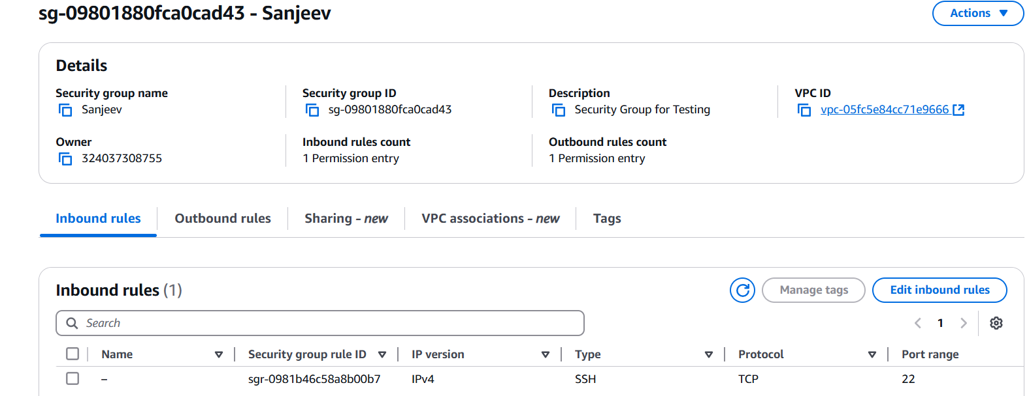

Step 4: Attaching the Security Group to the EC2 Instance
- Objective:
After creating and configuring the security group, the next step is to attach it to the EC2 instance. This establishes an inbound connection, enabling the instance to communicate with the configured security rules.
- Steps to Attach the Security Group:
  - Retrieve Necessary IDs:
    - Obtain the Instance ID of the EC2 instance to which the security group needs to be attached.
    - Retrieve the Security Group ID of the security group you created and configured in the previous step.
  - Use Boto3 to Attach the Security Group:
    - Using Boto3, the modify_instance_attribute() function can be used to associate the security group with the EC2 instance.
  - Verify the Attachment:
    - After executing the code, verify in the AWS Console that the security group is now attached to the EC2 instance.
- Outcome:
  - This establishes a functional inbound connection to the EC2 instance, ensuring that it adheres to the security group’s rules.
  - The EC2 instance is now accessible via SSH or any other protocols specified in the security group.
- Why This Step is Important:
  - Attaching the security group to the EC2 instance is a critical step in ensuring connectivity and functionality. Without this, the instance cannot communicate effectively or allow secure external access.
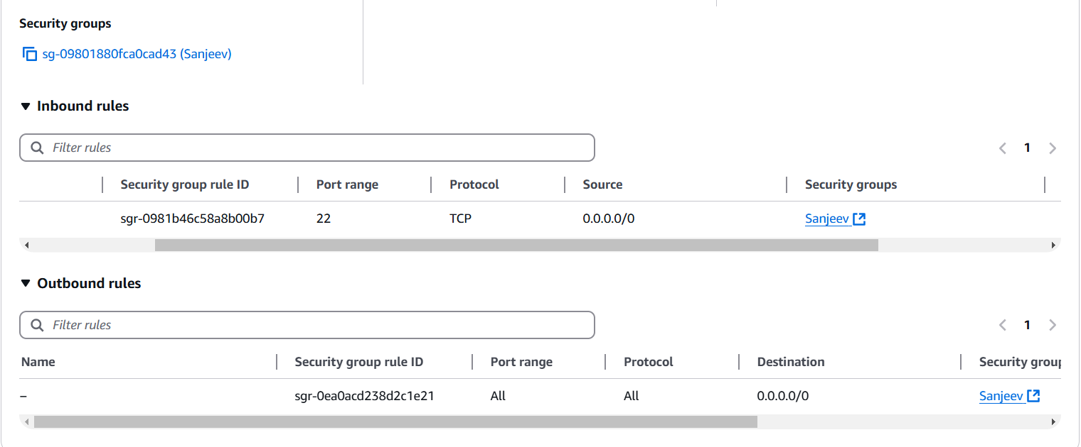

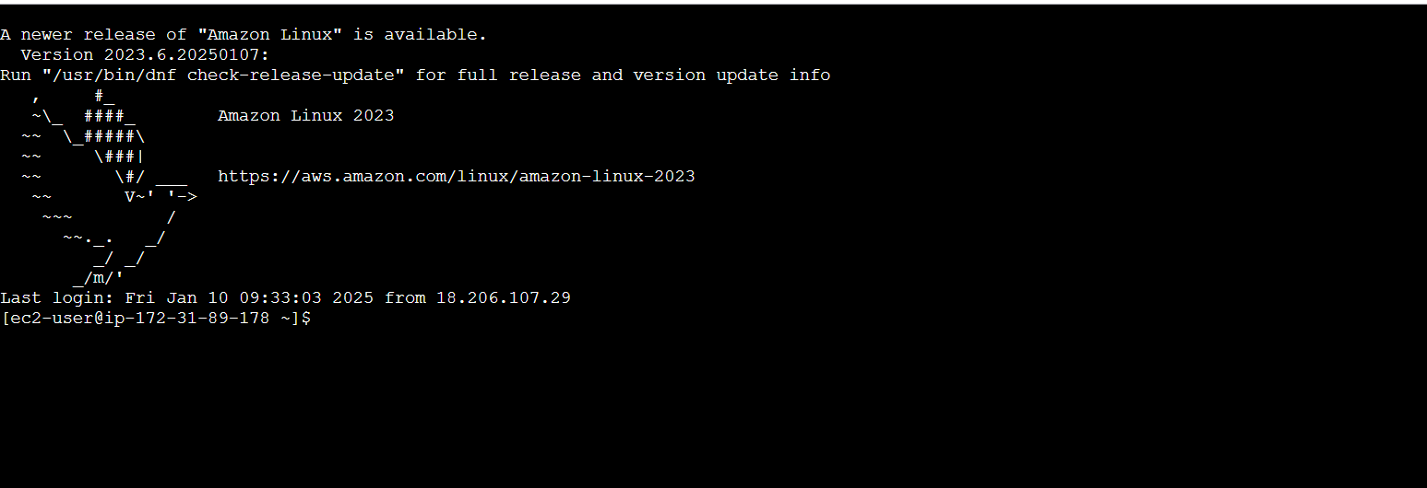

Step 5: Attaching the Security Group and Instance Monitoring
- Attaching the Security Group to the EC2 Instance:
  - Objective:
After creating the security group and configuring its rules, the next step is to attach it to the EC2 instance to establish a functional inbound connection.
  - Process:
    - Retrieve the Instance ID of the EC2 instance.
    - Retrieve the Security Group ID of the security group.
    - Use the modify_instance_attribute() function in Boto3 to attach the security group to the instance.
  - Outcome:
This step ensures that the EC2 instance adheres to the security rules set in the security group, enabling secure inbound traffic.
- Creating a Function to Monitor Instance Status:
  - Objective:
To efficiently manage the EC2 instance, I created a function to monitor its status and perform key operations like starting, stopping, and terminating the instance.
  - Functionalities:
    - Start Instance: Checks if the instance is in a stopped state and starts it if required.
    - Stop Instance: Safely stops the instance when not in use.
    - Terminate Instance: Permanently deletes the instance when no longer needed.
  - Implementation:
    - Used the describe_instance_status() function in Boto3 to fetch the current status of the instance.
    - Integrated conditional logic to perform actions based on the instance's current state.
  - Why This Is Important:
    - Monitoring the instance status is critical when deploying ML models or handling user API requests.
    - For example, if an API call is made while the instance is stopped, it could lead to errors. The monitoring function ensures the instance is running before performing further operations.
- Outcome:
  - The EC2 instance is now well-managed with functionalities to handle its lifecycle.
  - This function minimizes downtime and ensures smooth execution of tasks, making the deployment more robust and efficient.

